H.T No
Regulations:
A17

Sreenidhi Institute of Science and Technology
(An Autonomous Institution)
Code No: 6CC01 Date: 08-Mar-2021 (FN)

B.Tech II-Year I- Semester External Examination, March/April - 2021 (Supplementary)
Electronic Devices and Circuits (EEE, ECE & ECM)

Time: 3 Hours Max.Marks:75

Note: a) No additional answer sheets will be provided.
b) All sub-parts of a question must be answered at one place only, otherwise it will not be valued.
c) Missing data can be assumed suitably.

ANSWER ANY 5 OUT OF 8 QUESTIONS. EACH QUESTION CARRIES 15 MARKS.

Bloom's Cognitive Levels of Learning (BCLL)

Remember | L1 | Apply | L3 | Evaluate | L5
Understand | L2 | Analyze | L4 | Create | L6

 |  |  | BCLL | CO(s) | Marks
1. | a) | In a CRT the distance between the plates is 1cm, the length of the deflecting plates is 4.5cm and the distance of the screen from the plates is 33cm. If the accelerating voltage is 300V and the deflecting voltage is 50V, find the velocity of electron reaching the field, deflection produced on the screen and deflection sensitivity. | L5 | CO1 | [8M]
 | b) | Explain electrostatic deflection and sensitivity. | L2 | CO1 | [7M]
2. | a) | A full wave rectifier delivers 50W to a load of 200Ω. If the ripple factor is 1%, calculate the AC ripple voltage across the load. | L5 | CO2 | [8M]
 | b) | Differentiate the Avalanche and zener breakdown. | L4 | CO2 | [7M]
3. | a) | Derive the relationship between 𝛂, β, 𝝲. | L3 | CO3 | [8M]
 | b) | Explain the thermal runaway in BJT’s. | L2 | CO3 | [7M]
4. | a) | Compare JFET and MOSFET. | L3 | CO4 | [8M]
 | b) | An N-channel JFET has I​_{DSS​} = 8mA and V​_{P}=​ -5V. Determine the minimum value of V_{DS}​ for pinch-off region and the drain current I​_{DS} for V​_{GS}=​ -2V in the pinch-off region. | L5 | CO4 | [7M]
5. | a) | Consider CE npn transistor amplifier with load R​_{L}=15​kΩ and a source resistance R​_{S}=1​kΩ. The h-parameters are h​_{ie}=1​KΩ, h​_{fe}=150, h_{​re}=1​x10⁻⁴​,  h​​_{oe}=20μ℧. Calculate the current gain, voltage gain, input and output resistance. | L4 | CO5 | [8M]
 | b) | Explain the frequency response of the CE amplifier. | L2 | CO5 | [7M]
6. | a) | Explain the operation of series voltage regulator. | L2 | CO6 | [8M]
 | b) | A Zener diode regulator in figure, is to be designed to meet the specifications :  I​_{L}=10mA, V_{o}=10volts and V_{in} varies from 30 to 50 volts. The Zener diode has​  V​_{Z} = 10volts and I​​_{ZK} knee current) = 1mA. Find R for satisfactory operation.​  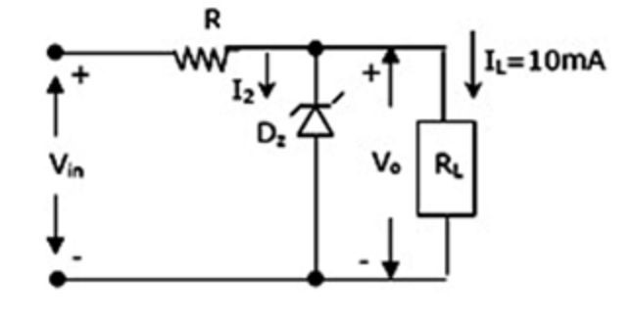 | L4 | CO6 | [7M]
7. | a) | An electron has a velocity of 2x10⁷​ m/s when it enters a magnetic field perpendicular to the direction of flux. If the flux density is 0.5mWb/m​. ²​.  Find the path radius of the path and time for one revolution. | L2 | CO1 | [5M]
 | b) | Compare the half wave and full wave rectifiers. | L3 | CO2 | [5M]
 | c) | Explain the input and output characteristics of CB configuration. | L2 | CO3 | [5M]
8. | a) | Explain the two transistor analogy of SCR. | L4 | CO4 | [5M]
 | b) | Explain how transistor acts as amplifier. | L2 | CO5 | [5M]
 | c) | Mention the applications of voltage multipliers. | L5 | CO6 | [5M]

-- 00 -- 00 –

